**CURRICULUM VITAE**

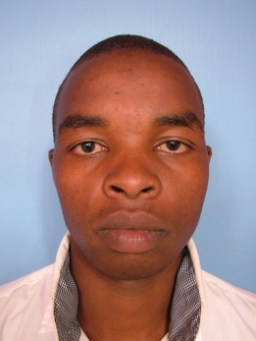

Name : **SAMMY KARIUKI GACHOKA**

Mobile : +254725518881

Email : [sammykariukigachoka606@gmail.com](mailto:sammykariukigachoka@gmail.com)

Date of Birth : 10/10/1994

Nationality : Kenyan

Marital Status. : married

Language : fluent in English and Swahili

**APPLIED POSITION ; Professional painter**

|  |  |  |  |
| --- | --- | --- | --- |
| **PERSONAL ATTRIBUTES** | | Polite, well spoken and hardworking person with a vast experience of working in a busy environment. Approachable, cheerful and possessing good observational skills as well as the ability to work alone and also as a part of a team. | |
|  |  | | |
| KEY SKILLS | | * Knowledge of different types of paints and their usage, eg undercoats, Supergloss, Silk Vinyl, Permaplast, Covermatt, Roof paints etc. * Working knowledge of indoor and outdoor paints. * Vast experience in indoor painting, outdoor painting and branding. * Signwriting. * Good interpersonal and communication skills. * Flexible and punctual. * Have a passion for work. * Ability to work in different locations. * A decision maker, well organized, resourceful, and works well independently. | |
| **CAREER HISTORY** | | DUTIES AND RESPONSIBILITIES | |
| **Oct –Dec 2012**  **Crown Paints Ltd.** | | * Painting and branding of buildings for Safaricom Ltd in the Mt. Kenya region towns in Meru and Nanyuki. * Use of stencils, preparation of drawing sketches according to different painting and branding areas. | |
| **April, August 2012** | | * Indoor painting of houses and shops. * Outdoor painting and branding of shops in Bahati town. | |
| **Oct – Dec 2012** | | * Sign-writing, painting and branding of shops in Gilgil and Naivasha towns. * Use of stencils, drawing sketches, draw-painting. | |
| **April, August 2013** | | * Sign-writing, painting and branding of shops in Nakuru town suburbs. | |
| **April, Aug 2014** | | * Painting indoors and outdoors of newly finished houses, Real Estates. | |
| **Nov 2014 – to date.** | | * Painting of houses, indoors and outdoors in newly finished Real Estates, Nakuru. | |
| *AREAS OF EXPERTISE* | | Different operations of kinds of paints. Vast experience in indoor and outdoor buildings-painting. Sign-writing and branding. | |
|  | | **EDUCATION BACKGROUND** | |
|  | |  | |
| 2014 | | Kurungu Secondary School | KCSE |
| 2009 | | KCPE Nyakiambi Primary School | KCPE |

HOBIES

* Travelling to new places.
* Interacting with others.
* Charity work.
* Reading journals.

Referees: Available on Request

